GREETINGS!

The following contains information and procedures for beginning a Padre Pio Prayer Group at your parish according to the rules and regulations of the International Association of Padre Pio Prayer Groups whose headquarters is located in San Giovanni Rotondo, Foggia, Italy, at the Casa Sollievo della Sofferenza (Home For The Relief of Suffering).
TABLE OF CONTENTS

Any documents contained in this procedure can be put into a binder to create a source of reference the Prayer Group can refer to.

- WELCOME
- HOW TO BECOME A SPIRITUAL CHILD OF PADRE PIO
- HISTORY OF THE PRAYER GROUPS
- SPIRITUAL CHILD/PRAYER GROUP REQUISITES
- PROCEDURE FOR BEGINNING A PRAYER GROUP
- STATUES/ARTICLES
- WEBSITE/BROCHURE

The following are important offices:
Centro Internazionale Gruppi Di Preghiera Di Padre Pio
Viale Cappuccini 172
Casa Sollievo della Sofferenza
71013 San Giovanni Rotondo, Italy
Tel. +39 0882410486 Tel. +39 0882410252 Fax +39 0882452579
Email: centrogruppidipreghiera@operapadrepio.it
Website: www.operapadrepio.it/gruppidipreghiera
Facebook: www.facebook.com/gruppidipreghiera/
Whatsapp: +39 341115695
- - - - - - - - -
Padre Pio Prayer Groups
St. Francis of Assisi
1901 Prior Road
Wilmington, Delaware 19809
Tel: (302) 798-1454 Websitewww.pppg.org Email: pppgusa@gmail.com
I.

WELCOME

It is with great pleasure I present the following information and procedures for establishing a Padre Pio Prayer Group at your parish. The steps are many, but not complicated. Once your paperwork is complete, your bishop has blessed your group and paperwork sent to Headquarters and registered, the Association will send a Letter of Acceptance and Certificate of Recognition with information regarding what the Association is doing internationally. It is very exciting work and deeply, spiritually gratifying.

II.

HOW TO BECOME A SPIRITUAL CHILD OF PADRE PIO

The Association defines a Spiritual Child of Padre Pio as one who commits to:
*Live on God’s Grace and make use of the Sacraments of the Eucharist and Reconciliation
*Live one’s faith in words and deeds in a true Christian life
*Love Jesus crucified, the Most Blessed Sacrament, the Most Blessed Mother, the Holy Father
and the Roman Catholic Church
*Be pro-active and sincere in a spirit of charity toward all

III.

HISTORY OF PRAYER GROUPS

As you find others who are Saint Pio’s Spiritual Children, the need for his prayer group will be a natural outflow of your love and faith for Saint Pio. It is important to know the history and purpose of the Group to better understand its direction. The history of the Padre Pio Prayer Groups below is a document from the National Headquarters of Padre Pio Prayer Groups, National Office. Its office information is:
Padre Pio Prayer Groups
St. Francis of Assisi
1901 Prior Road
Wilmington, Delaware 19809
Tel: (302) 798-1454 Websitewww.pppg.org Email: pppgusa@gmail.com
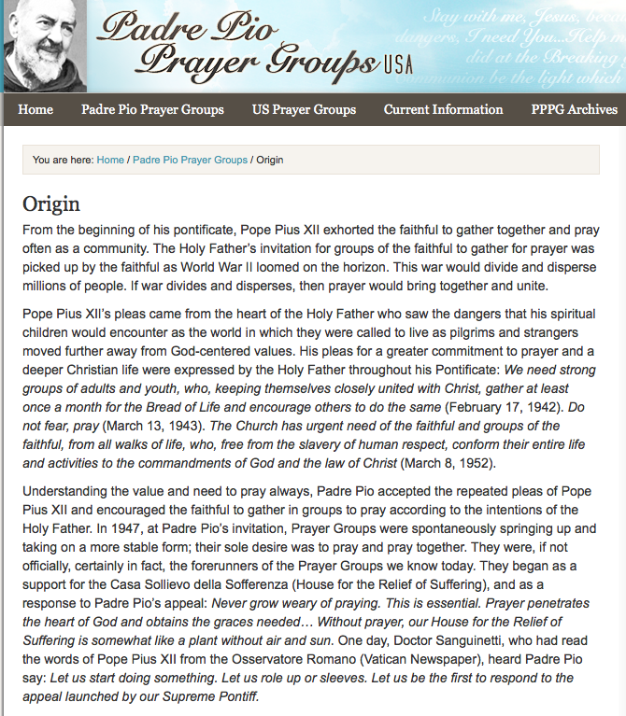

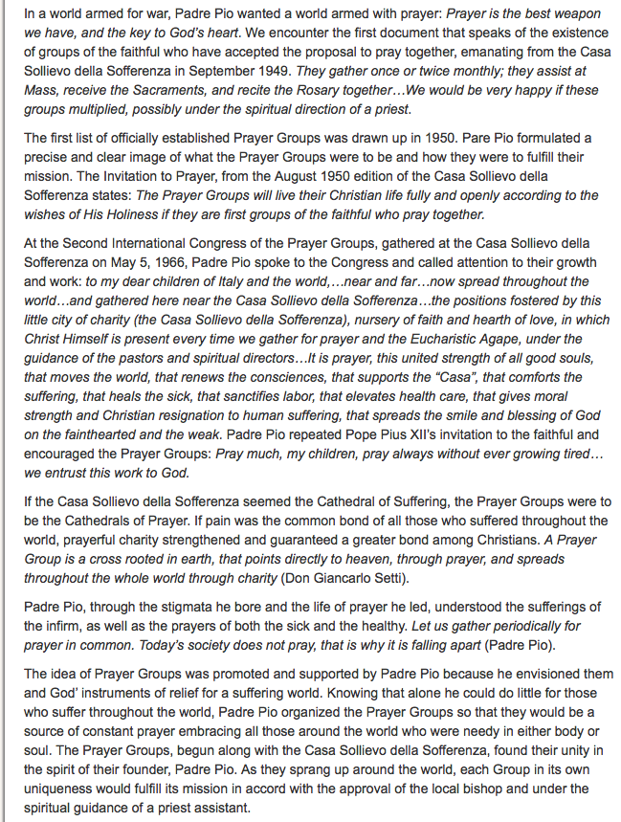

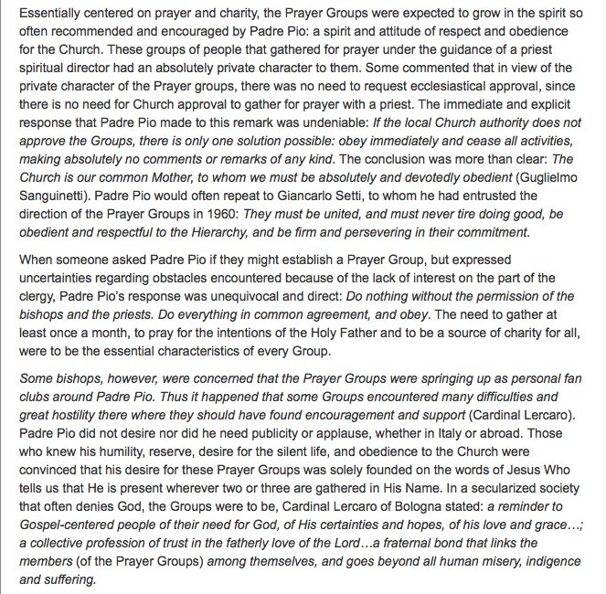

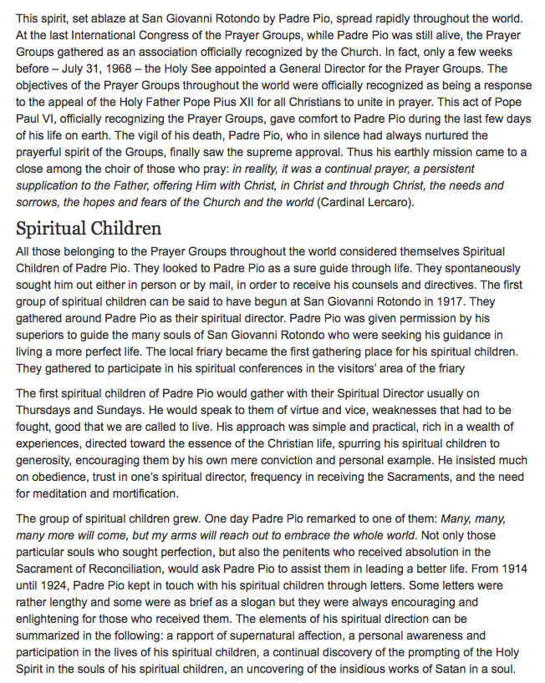

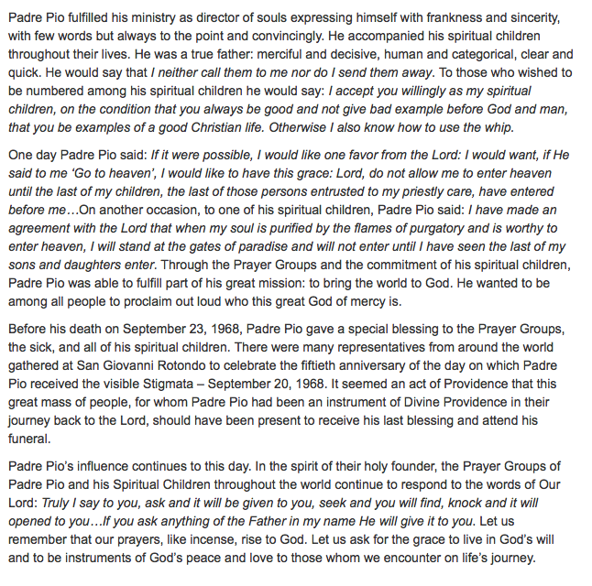

IV.
SPIRITUAL CHILD/PRAYER GROUP REQUISITES
From the Desk of the Coordinator
NATIONAL OFFICE
St. Francis of Assisi Friary
1901 Prior Road
Wilmington, Delaware 19809
website: pppg.org email: pppgusa@gmail.com
Padre Pio Prayer Groups National Office
Re: ‘Spiritual Child’ and Prayer Group requisites
Dear Spiritual Children and Friends of Padre Pio, The Lord give you His peace!
March 2015
The following excerpts are taken from the book Padre Pio of Pietrelcina “everybody’s cyrenean”, written by Alessandro of Ripabottoni. They speak of the origin and purpose of the Prayer Groups organized by our Founder and Father Padre Pio of Pietrelcina. Hopefully, this may respond to some questions concerning being a ‘Spiritual Child of Padre Pio’ and being Spiritual Children of Padre Pio as members of the Prayer Groups.
‘Spiritual Child of Padre Pio’
The title of ‘Spiritual Child of Padre Pio’ has been somewhat misunderstood. Requisites for a ‘Spiritual Child’ were laid down by Padre Pio himself:
- To live intensely on God’s grace and make use of the sacraments of Eucharist and Reconciliation often
- To live one’s faith in words and actions, in a true Christian life
- To love Jesus Christ Crucified, the Most Blessed sacrament, Our Blessed Mother, the holy Father and the Roman Catholic Church
- To be pro-active and animated by a sincere spirit of charity towards all
The conditions for a ‘Spiritual Child of Padre Pio’ do not involve donations or belonging to specific groups, as long as the person accepts and fulfills Padre Pio’s intentions mentioned above.
Padre Pio Prayer Groups - Those who belong to the Padre Pio Prayer Groups are spiritual children of Padre Pio by the fact that all the members commit themselves to fulfill the will of Padre Pio as members of a Group.
The essence of the Prayer Groups lies in the love which unites them ...
During the dark hours of his first year as Pope, Pius XII exhorted (an exhortation which was insistently repeated during the following years) the faithful to turn to prayer which is the supreme strength and the surest hope for all ...
But the Holy Father insistently exhorted ... everyone, to pray: the suffering members of the Church ... legions of children; families in city and country; Catholic employers and owners of small businesses; the young ... He said to all: Raise your hands and hearts to God: Nobody can observe the laws of God for a long time and avoid grievous sin without prayer; prayer is the strongest and most invincible weapon against all the dangers and assaults of the world. You must pray, pray, pray. Prayer is the key to the treasure of God; it is the weapon of battle and victory in the fight against evil. Pius XII exhorted all to form a chain of praying and penitent people; men in whom prayer and the thought of God has become second nature and the daily food of their souls ... to prepare a chain of strong men and young people who, uniting themselves strongly with Christ, et least every month, nourish themselves with the Bread of Life and even induce others to follow their example (17 February 1943) ...
In the fight between good and evil even today is the Church’s task a secure, and continuous support cannot be found in those who approach Holy Communion only once a year, and we advise you to gather together to form groups of men, women, and young people, who frequent, at least monthly, the Eucharistic Food and who lead as many friends and acquaintances as possible there (13 March 1943).
What the Church urgently needs are faithful, and groups of faithful, from all walks of life who, free from the slavery of human respect, conform the whole of their lives and activities to the commandments of God and the laws of Christ (8 March 1952).
The sorrowful and grief-stricken appeals of Pope Pius XII ... foretold the formation of Prayer Groups, just as Padre Pio immediately saw: Groups of faithful will fully and openly live Christian lives, as His Holiness wishes, if they are first groups of people who pray together. And from this thought (Padre Pio) turned to action: Let’s get going! Let’s roll up our sleeves and immediately answer this appeal which has been sent out by the Roman Pontiff.
And so the Prayer Groups were born. They were closely knit groups of praying and penitent people ... men and women and young people ... The structure of this movement was underlined by Padre Pio himself in a declaration of 5 May 1966: breeding grounds of faith and sources of love, in which Christ Himself is present every time souls unite in fraternal prayer under the guidance of their directors, pastors and spiritual directors...
In August 1950, the official appeal for the establishment of the Prayer Groups on a wider scale goes out from San Giovanni Rotondo, and this was followed by some clarifications and general instructions. The Prayer Groups were formed to better renew the Christian life around us (love of God and our neighbor), through communal prayer ... they fraternally agree to unite, in order to pray together, at least once a month, under the spiritual direction of a priest, with no other goal than that of praying, and inviting other friends and acquaintances to pray ...
As regards the direction of the Prayer groups, this should be carried out by a priest, and this in fact is indispensable, so that the spontaneous desire to unite in prayer be carried out, rigorously and faithfully according to the principles and norms of the Holy Catholic Church to which reverence and strict obedience is due. ... to avoid all possible deviations and personal initiatives which, even though they may be purely inspired by sound faith and zeal, could in some way, falsify the nature and aims of the Prayer Groups.
It is a disciplinary rule that all good Catholics refrain from forming Prayer Groups without the permission of the Bishop or (authority) of the area in question.
The Prayer Groups propose to follow the general principles of Padre Pio’s Franciscan spirituality, with full adhesion to the Church Magisterium, prayer with the church with active participation in the liturgical and sacramental life; reparation through participation in the suffering of Christ concrete and active charity for the relief of those who suffer ...
The association’s Statutes bears Padre Pio’s handwritten approval (Milan, 8 February 1965): I have read, approved, and blessed it. Padre Pio . It was established under the direction of a priest for the sanctification of its members and or the realization of charitable and apostolic works in the spirit and example of Padre Pio of Pietrelcina.
(The Prayer Group) is directed and administered by a council made up of a president, assistant, and delegates responsible for the various activities which are spiritual, charitable and apostolic.
This excerpt does not answer all questions but it does mention the basics that are fundamental to the Association as a whole and to each Prayer Group. It helps to be reminded. Another version from another author concerning the origin of the Prayer Groups can be found on the website (pppg.org).
God bless you, and may Our Lady and Padre Pio accompany us on our Lenten Journey.
Peace and Blessings Fr. Francis A. Sariego, O.F.M. Cap. National Coordinator

V.

PROCEDURE FOR BEGINNING A PRAYER GROUP

When there are five people willing to commit to a prayer group, you must then find a priest who is willing to direct your group. He will be called the Spiritual Director. He may, or may not, be a priest from your parish. The basic purpose of a director is to keep the group true to Saint Pio’s purpose of the prayer group and the teachings of the Catholic Church. Before the group can exist, it must receive a blessing from the head parish priest. Be ready to state the difference between the Padre Pio Prayer Group and other prayer groups.

Once a director is found, the group must choose officers from the group. The following are offices:

*Group Leader
*Vice-Group Leader
*Secretary
*Web Person (optional)
*Leader of Young People (optional)

Below are three documents from the National Headquarters of Padre Pio Prayer Groups (PPPG.org). The first explains the purpose and need for a Spiritual Director; the second is the Registration Form needed to register the group with the Association. The third is an Activity Form used to report the Group’s activities to San Giovanni periodically. Once the Registration Form is completed, send it to the bishop of your diocese with a cover letter on parish letterhead explaining your purpose and desire to form a prayer group. If you need assistance writing to your bishop, your Director should have his address and what should be stated. The letter our group wrote and the Bishop’s response can be downloaded from our website FRIENDSOFPADRE PIO.WEEBLY.COM under the Our Lady of the Assumption page.
Once the group has the blessing from the bishop, the form must be sent to two places: the Centro Gruppi address in San Giovanni, Italy, and the National Headquarters in Delaware (see addresses previously given) along with cover letters explaining the purpose and process. Make copies of all documents sent and received. When the Letter of Recognition from San Giovanni is received, forward a copy to the National Headquarters. Thereafter, send monthly Activity Reports to San Giovanni (Activity Report enclosed).

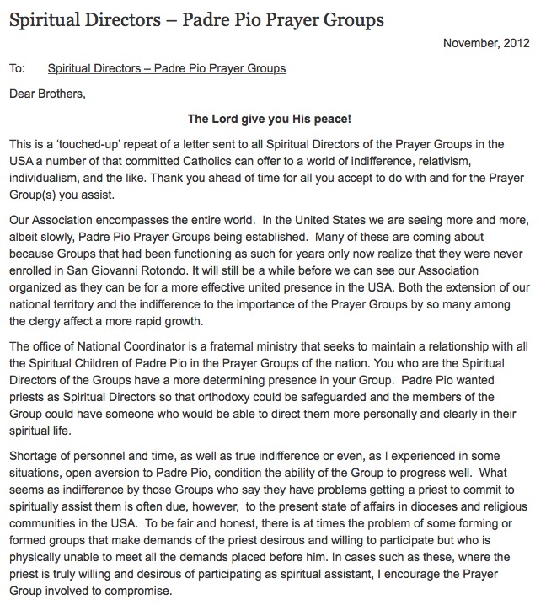

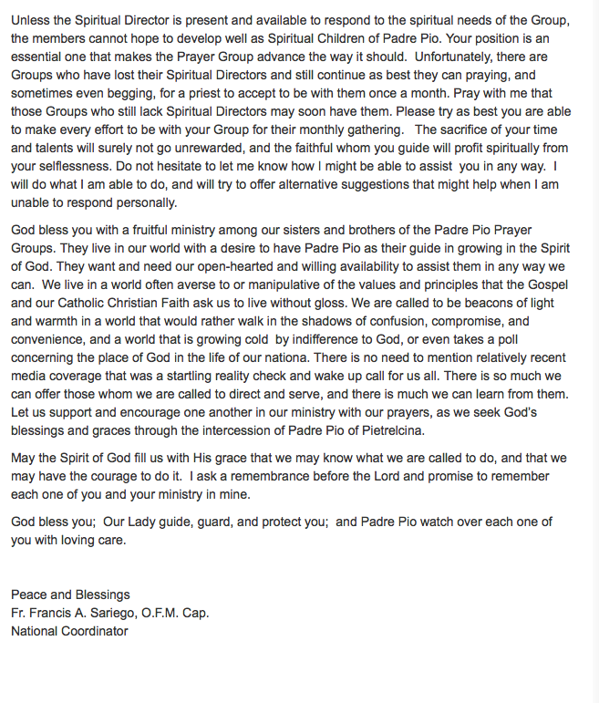

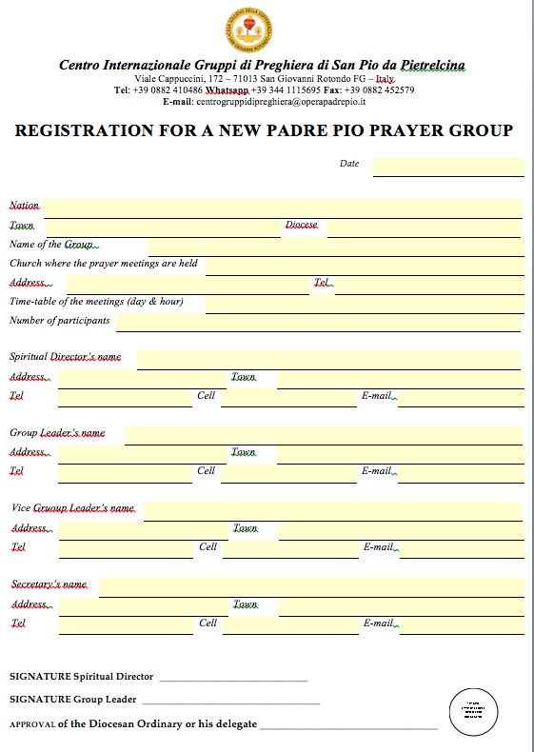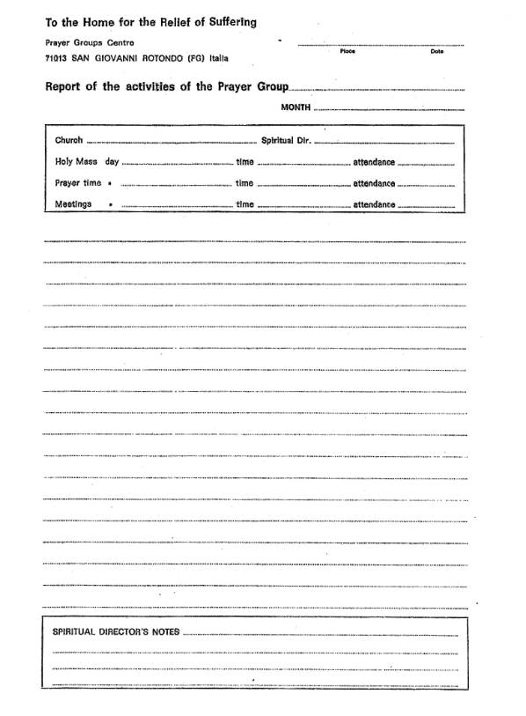
VI.

STATUES/ARTICLES

As all associations do, the International Association of Prayer Groups has a constitution with Articles and Statues. Below is a document from the National Association listing the Articles and Statues. Following the Articles provided by the National Association is a simplified version written by the Padre Pio Prayer Group of Our Lady of the Assumption in Claremont, California. The Statues from the National Headquarters have been revised and are dated 2018. They are lengthy. Our Group chose to rewrite them into shorter, more concise paragraphs keeping to the intent of the Article. All Prayer Groups must follow the Articles, but you may choose to use the shorter versions. Our Statues and Articles are posted on our website and may be downloaded.

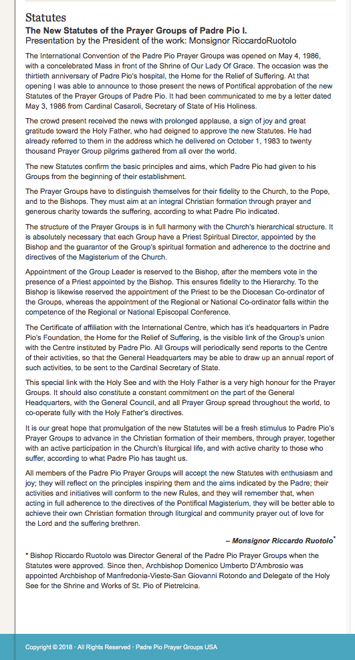
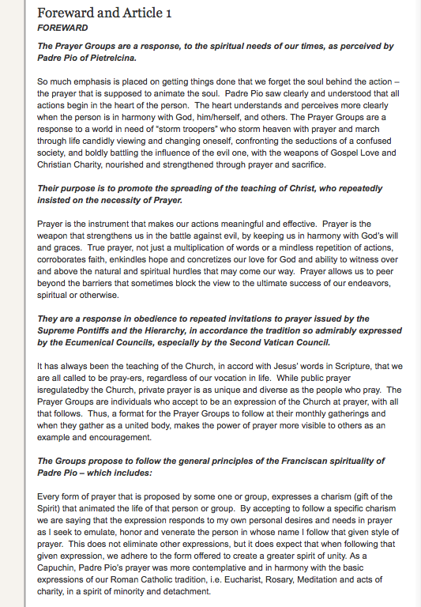
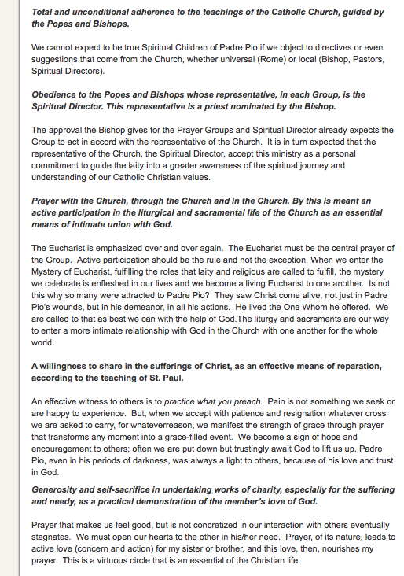
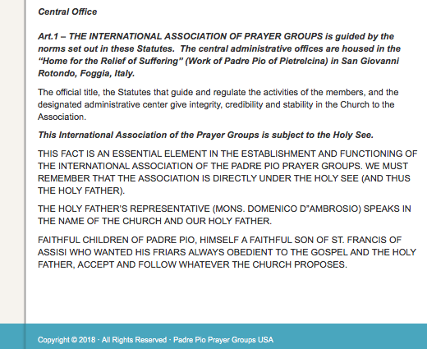
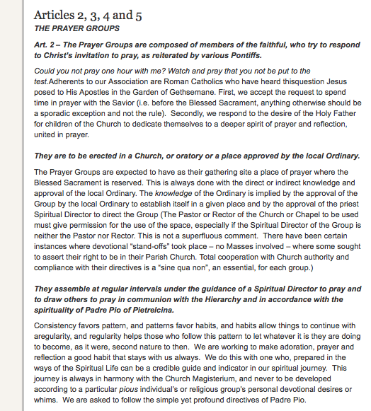

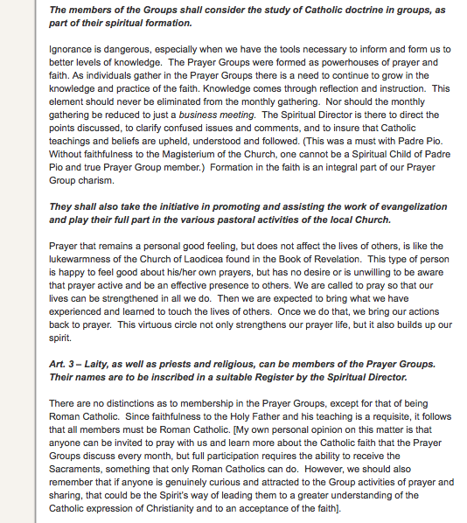

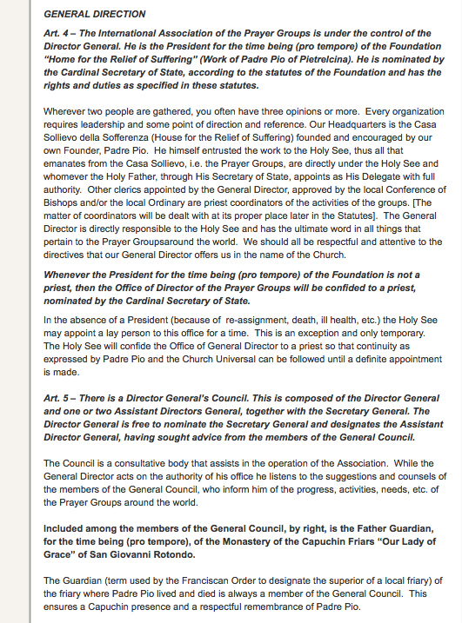
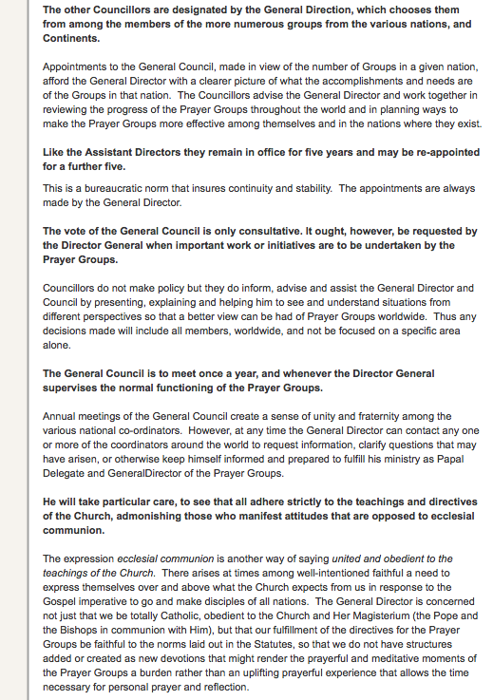
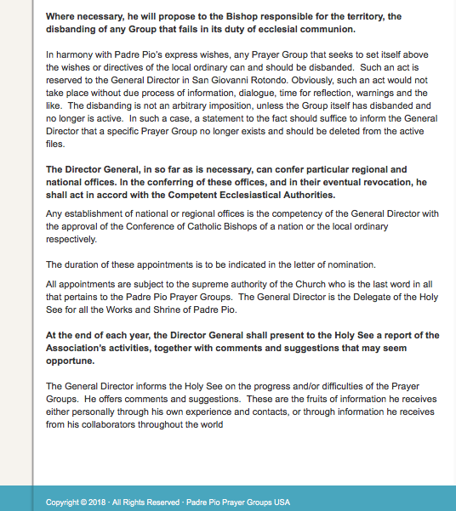

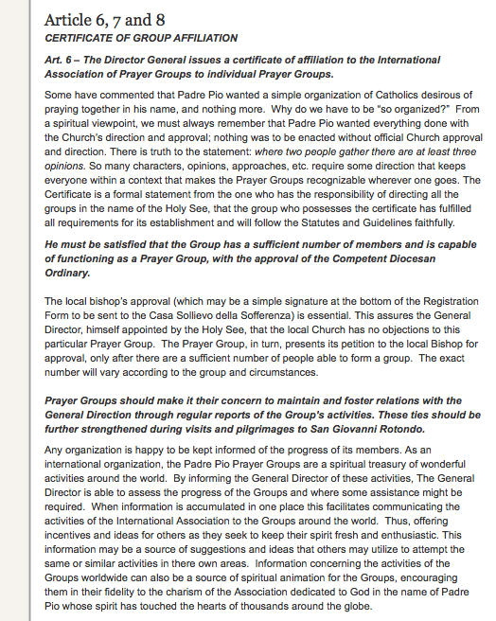

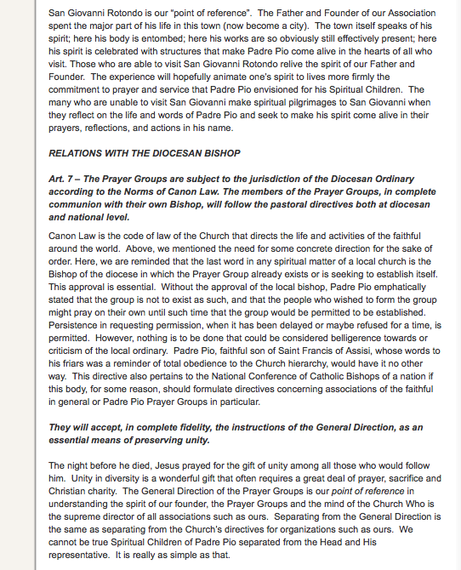

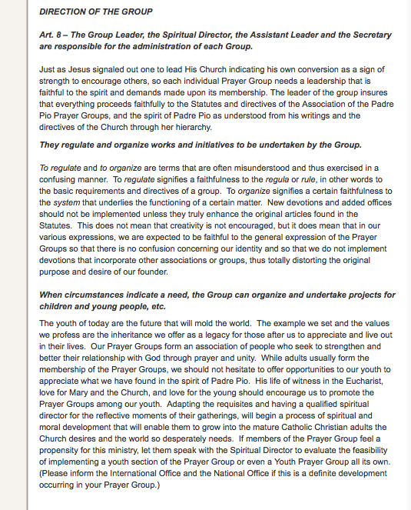
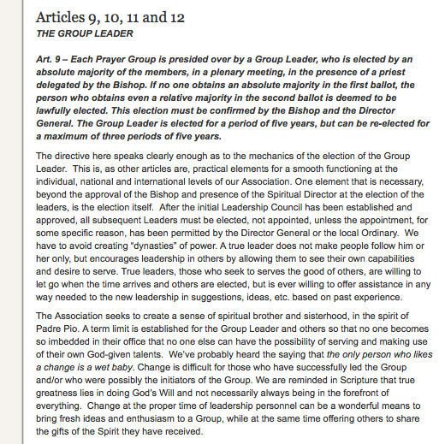

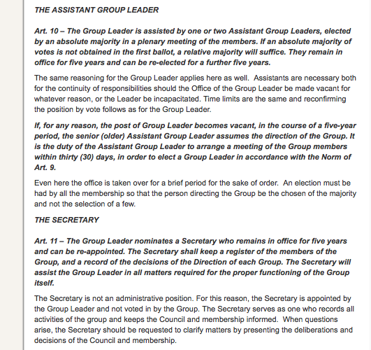

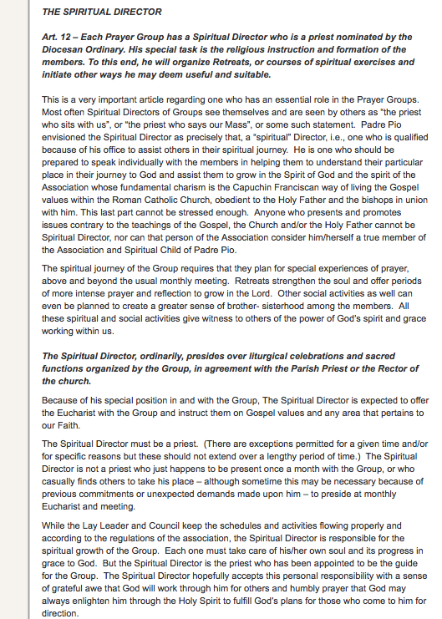

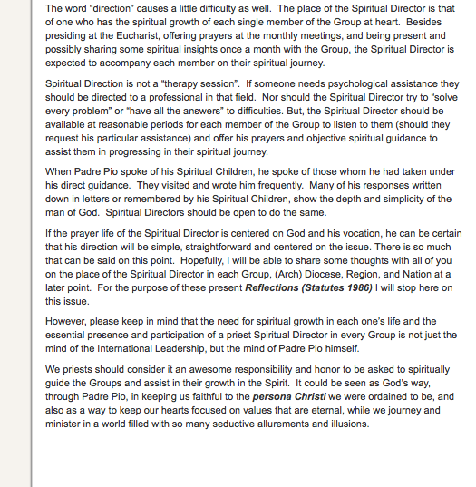

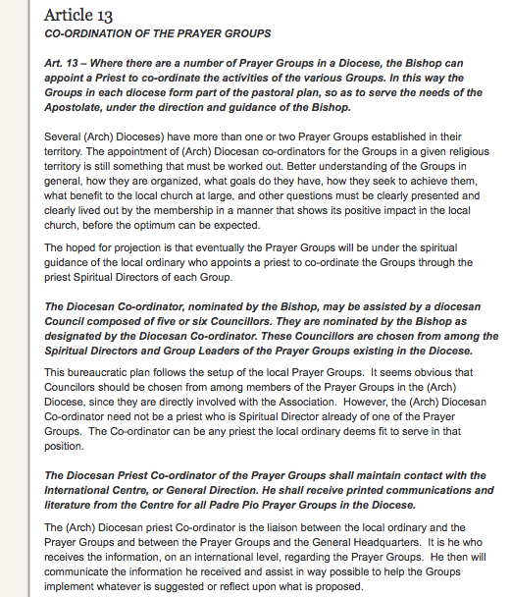

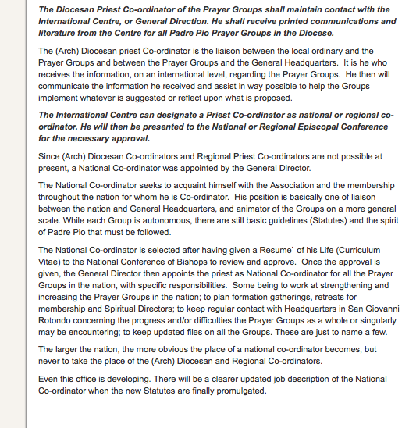

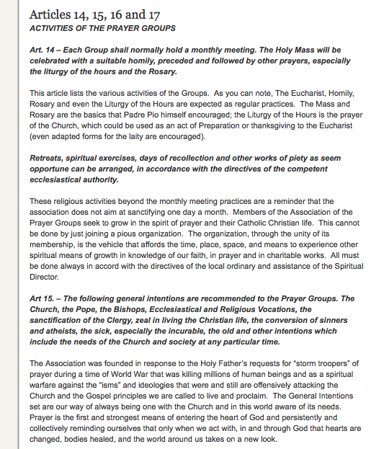

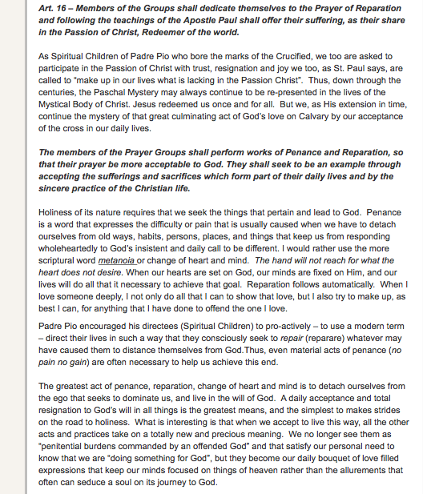

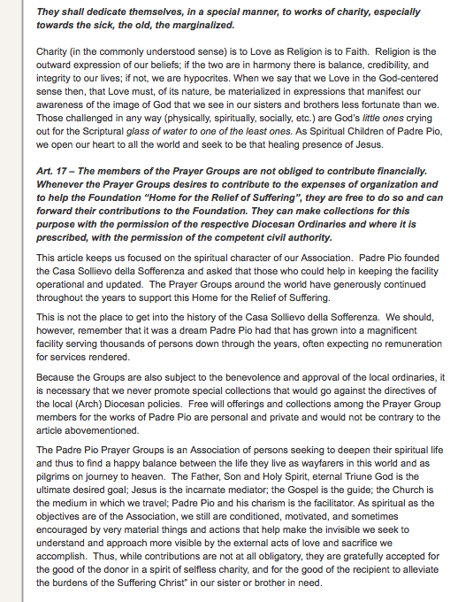

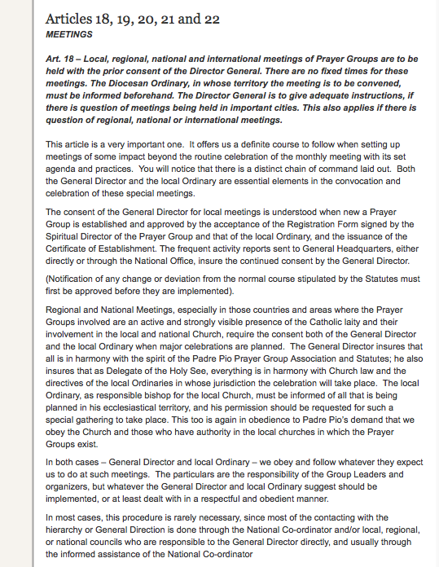

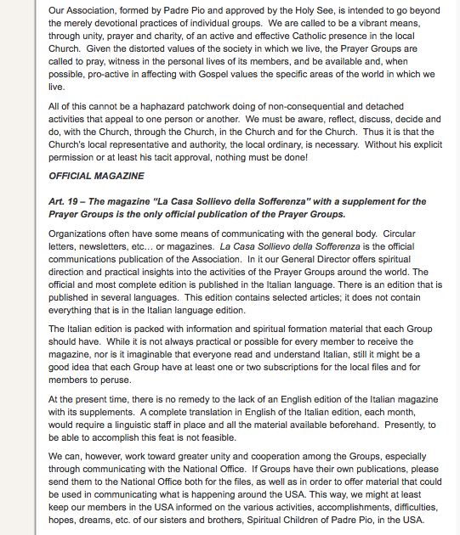
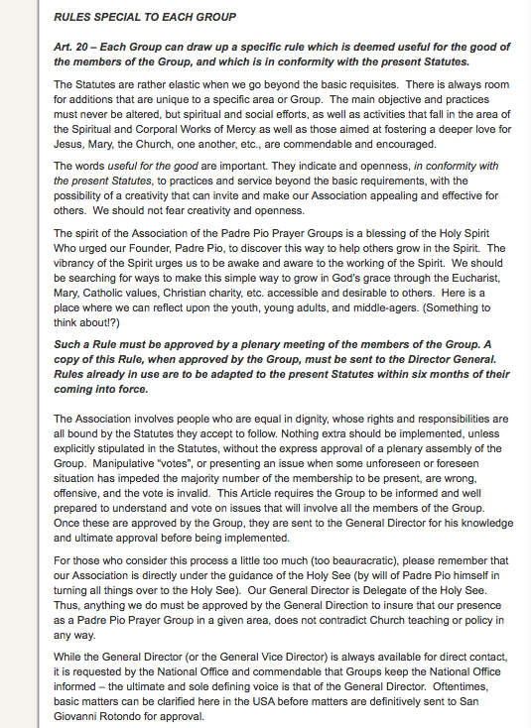
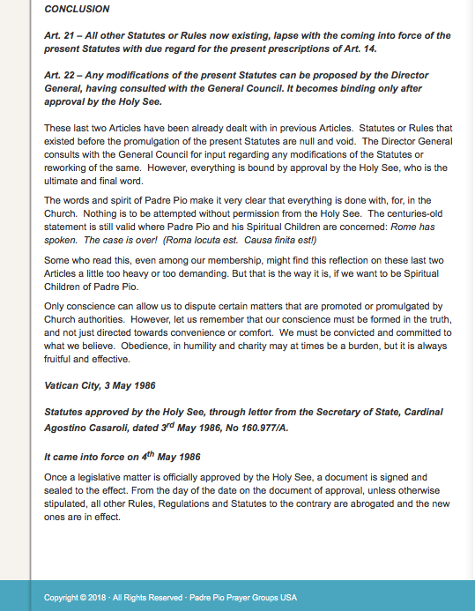
OUR LADY OF THE ASSUMPTION PADRE PIO PRAYER GROUP

STATUTES AND ARTICLES OF THE PADRE PIO PRAYER GROUP

The following Statutes govern the purpose, direction, accountability and formation of the Our Lady of the Assumption Padre Pio Prayer Group located in Claremont, California. They are based on the International Association of Prayer Groups housed in the Home for the Relief of Suffering in San Giovanni, Foggia, Italy.

FORWARD

The following tenets hold true for the Our Lady of the Assumption Parish (OLAP) Padre Pio Prayer Group:

-The Prayer Groups are a response to the spiritual needs of our times as perceived by Padre Pio

-Their purpose is to promote the spreading of the teaching of Christ with the emphasis on prayer and Redemptive Suffering: Prayer with the Church, through the Church, and in the Church

-They are a response in obedience to the request by Supreme Pontiffs, and the Second Vatican, to pray for the Church and the world

-The Groups follow the principals of the Franciscan spirituality of Padre Pio in the Roman Catholic tradition to include: the Eucharist, Rosary, meditation, and acts of charity

-The Group holds total and unconditional adherence to the teachings of the Catholic Church as guided by the Holy See and Bishops whose representative in each Group is the Spiritual Director, a priest nominated by the Bishop.

-The Group will actively participate in the liturgical and sacramental life of the church

-The group will demonstrate a willingness to share in the suffering of Christ as a means of reparation for others through the activities of the Group

-The leadership of the group will consist of a Spiritual Director, Group Leader, Assistant Leader and Secretary

-The focus of the Prayer Group is determined by its Spiritual Director

ARTICLES

Central Office: International Association of the Prayer Groups

Art. 1

The Our Lady of the Assumption Padre Pio Prayer Group is guided by the International Association of Prayer Groups (IAPG) housed in the Home for the Relief of Suffering in San Giovanni, Foggia, Italy.

The International Association of the Prayer Groups is subject to the Holy See.

Prayer Groups

Art. 2

The Prayer Group is composed of members of the faithful who respond to the invitation of the Holy See to pray.

The Group will meet in a place approved by the Spiritual Director where the Blessed Sacrament is reserved.

The Group will assemble at regular intervals to pray and draw others in communion in accordance with the spirituality of Padre Pio.

The members shall grow spiritually through reflection and instruction of the Catholic faith under the direction of the Spiritual Director.

The Group will promote and assist in the work of evangelization and will report

Art. 3

Laity, priests and religious may be members of the Prayer Groups with their names inscribed in a register.
Art. 4

The IAPG is under the control of the Director General, nominated by the Cardinal Secretary of State who is under the direction of the Holy See. The Group will report activities to the Director General as directed by the IAPG. The General Director is the Delegate of the Holy See for all the Works and Shrine of Padre Pio.

Art. 5

The Director General’s Council, consisting of the Director General, a Secretary General and two Assistant Directors, will meet once a year in San Giovanni, Rotundo, Italy, to assess the status of prayer groups around the world. When necessary, the Director General may request of a local bishop the disbanding of a group if such a group is out of the norm, but not without due process. At the end of the year, the Director General will present a report of the IAPG activities to the Holy See.

Certificate of Group Affiliation

Art. 6

The Director General will issue a Certificate of Affiliation to individual groups when requirements are met.

Art. 7

The Prayer group is subject to the jurisdiction of the Diocesan Ordinary according to the Norms of Canon Law. The members, in complete union with their own Bishop, will follow the pastoral directives at the diocesan and national level.

Art. 8

The Spiritual Director, the Group Leader, the Assistant Leader and the Secretary are responsible for the administration of each Group.

Group Leader

Art.9

In the presence of the Spiritual Director, the Group Leader is elected by the majority of members for a term of five years, and can be re-elected for a maximum of three periods of five years. All elections and activities must be reported to the Director General via the International Association of Prayer Groups, San Giovanni, Foggia, Italy.

Art. 10

In the presence of the Spiritual Director, the Assistant Group Leader is elected by the majority of members for a term of five years, and can be re-elected for a maximum of two periods of five years. All elections and activities must be reported to the Director General via the International Association of Prayer Groups, San Giovanni, Foggia, Italy. If the Group Leader position becomes vacant, the Assistant Group Leader assumes the vacant position. It is the duty of the Assistant to arrange a new vote within thirty days of the vacancy.

Art. 11

The Group Leader nominates a Secretary who remains in the office five years and can be re-appointed. The Secretary shall keep a register of the members, and a record of the Group’s activities.

Art. 12

The Group will have a priest who is the Group’s Spiritual Director nominated by the Diocesan Ordinary. His task is the religious instruction and formation of the members. He directs the spirituality of the Group. This may include organizing retreats, spiritual exercises, orchestrating Mass, conducting the Rosary, Chaplet of Mercy, spiritual and social activities, evangelization, and teaching.

Co-Ordination of Prayer Groups

Art. 13

If the Diocese has a number of Prayer Groups, the Bishop can appoint a priest to coordinate the various groups.

Activities of the Prayer Groups

Art. 14

The group will meet at least once a month with the Holy Mass celebrated, preceded by other prayers such as the Rosary and Liturgy of the Hours. Retreats, spiritual exercises, works of piety/self-sacrifice/charity, prayer, social time can be arranged.

Art. 15

The following are recommended to the Group for prayer: the Church, Holy See, Bishops, Ecclesiastical and Religious Vocations, in living the Christian Life, conversation of sinners, the ill and poor.

Art. 16

The group shall dedicate itself to the Prayer of Reparation, and be reparable souls. It shall offer its suffering as its share in the Passion of Christ following the teaching of Paul: “Now I rejoice in my sufferings for your sake, and in my flesh I complete what is lacking in Christ’s afflictions for the sake of His Body, that is, the Church. (Colossians 1:24). The Group shall perform works of penance and reparation to make its prayer more acceptable to God, and seek to be an example through accepting the sufferings and sacrifices that are part of its daily life, and be the healing presence of Jesus.

Art.17

The collection of funds for any purpose is not mandatory, but allowed for the expenses of the Group or project they wish to fund. The IAPG encourages the funding of the Home For The Suffering Foundation. The collections are with the permission of the Diocesan Ordinaries. (to alleviate the burdens of the Suffering Christ in our sister or brother)

Meetings

Art. 18

Local, regional, national meetings of Prayer groups are to be held with the consent of the Director general.

Art. 19

The magazine “La Casa Sollievo della Sofferenza is the only official publication of the Prayer groups.

Art. 20

The Group may create a specific rule deemed useful for the good of the Group that is in conformity with the present Statutes. A copy of the rule must be sent to the Director General.

Conclusion

Art. 21

All statutes or rules now present lapse with any new rules generated by the IAPG.

Art. 22

Changes to existing Statutes can be proposed by the Director General at any given time. Such changes become binding after approval by the Holy See.

* * * * * * * * * *

VII.

WEBSITE/BROCHURE

It is important the group understands who Saint Pio is and why so many follow him. The website

WWW.FRIENDSOFPADREPIO.WEEBLY.COM

is written for those who do not know Saint Pio and would like to. It is also written for those who desire a deeper understanding. It contains explanations of penance, redemptive suffering, how the saints viewed suffering, quotes from Saint Pio, his biography, videos and an extensive list of references. It also contains a brochure and monthly newsletter – both may be downloaded from the website. Visit the page labeled Our Lady of the Assumption for letters and documents related to the procedure of writing to the local bishop.

Another purpose of the website is to network with other groups. If you would like to list your parish on the site, or create a link, you may submit your information to friendsofpadrepio@aol.com, or for any questions you may have.

- - - - - - - - - - - -

May our LORD, Mother Mary and Saint Pio guide you.

As a priest from San Giovanni told me, “Be sure Fr. Pio will give you all you need. Do not have any doubt this!”

- - - - - - - - - - - -

“You think you know my love for you, but you don’t know that it is much greater then you can imagine. I follow you with my prayers, with my sufferings and with my tears.” St. Pio

- - - - - - - - - - - -

“Then we shall be offering God the most beautiful, the most noble of prayers because our prayers will have sprung from sacrifice.” St. Pio

GOD BLESS!

